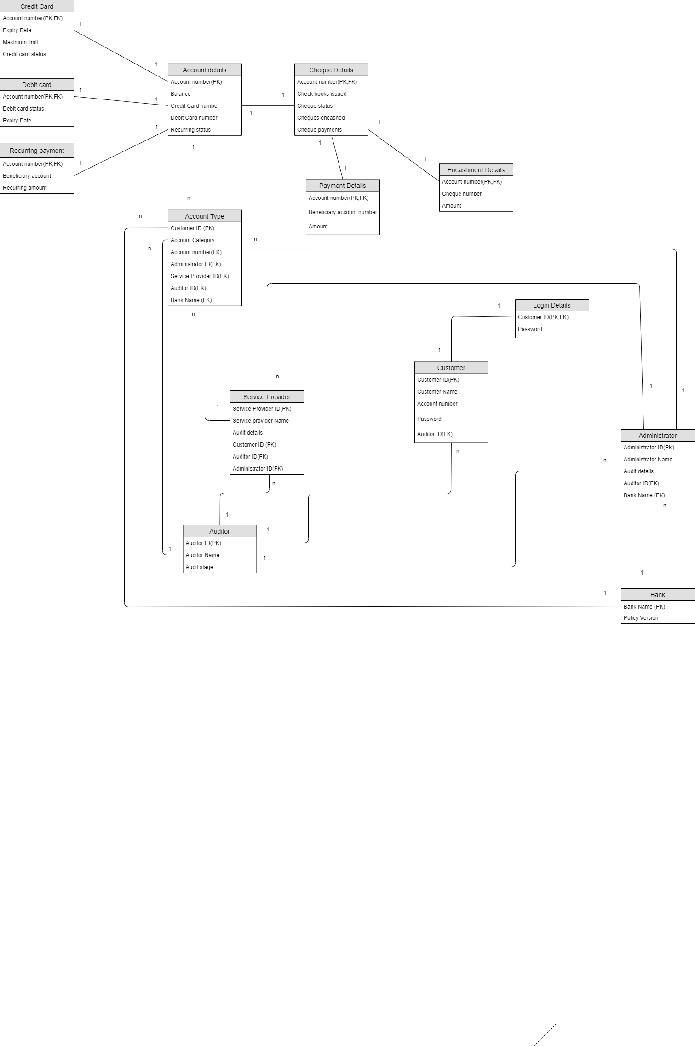

Relational SCHEMA

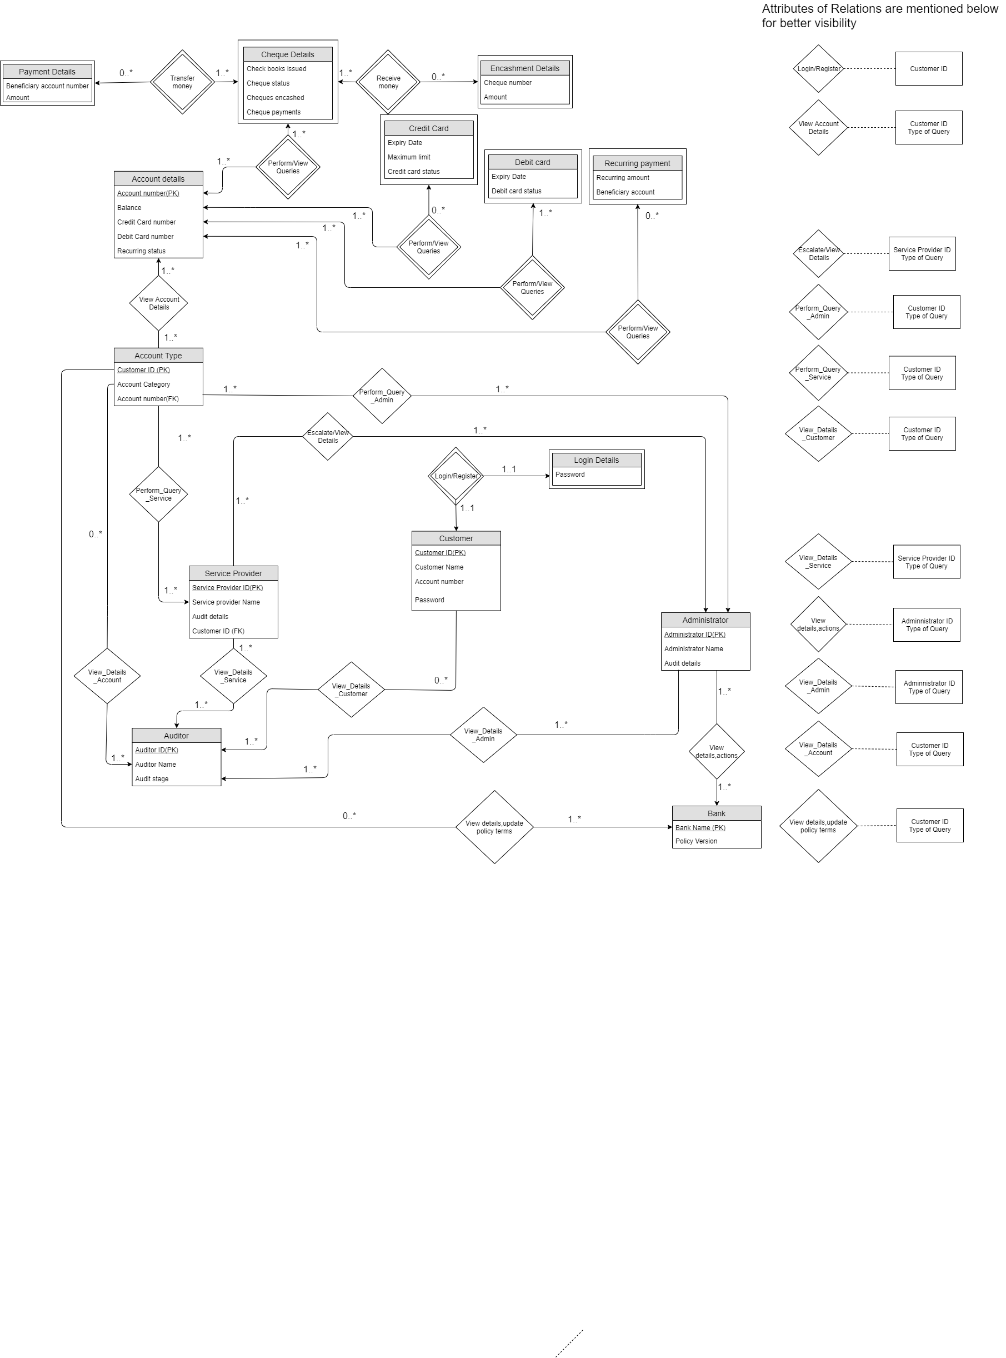

ER MODEL V3

1. Credit Card

CREATE TABLE Credit card(

Account Number CHAR(20) NOT NULL,

Expiry Date DATE,

Maximum Limit INTEGER

Debit Card Status BOOLEAN

PRIMARY KEY (Account Number),

FOREIGN KEY (Account Number) REFERENCES Account Details,

ON DELETE CASCADE)

1. Debit Card

CREATE TABLE Debit card(

Account Number CHAR(20) NOT NULL,

Expiry Date DATE,

Debit Card Status BOOLEAN

PRIMARY KEY (Account Number),

FOREIGN KEY (Account Number) REFERENCES Account Details,

ON DELETE CASCADE)

3)Recurring Payment

CREATE TABLE Recurring payment(

Account Number CHAR(20) NOT NULL,

Beneficiary account INTEGER,

Recurring amount INTEGER,

PRIMARY KEY (Account Number),

FOREIGN KEY (Account Number) REFERENCES Account Details,

ON DELETE CASCADE)

4)Login Details

CREATE TABLE Login Details(

Customer ID CHAR(20) NOT NULL,

Password CHAR(20),

PRIMARY KEY(Customer ID),

FOREIGN KEY (Customer ID) REFERENCES Customer,

ON DELETE CASCADE)

5) Payment Details

CREATE TABLE Payment Details(

Account Number CHAR(20) NOT NULL,

Beneficiary Account Number CHAR(20)

Amount INTEGER

PRIMARY KEY (Account Number),

FOREIGN KEY (Account Number) REFERENCES Cheque Details,

ON DELETE CASCADE)

6) Account details

CREATE TABLE Account details

(Account Number CHAR(20) NOT NULL,

Balance FLOAT(8,2),

Credit Card number INTEGER,

Debit Card number INTEGER,

Recurring Status BOOLEAN,

)

7) Bank

CREATE TABLE Bank(

Bank Name CHAR(20) NOT NULL,

Policy Version FLOAT(4,2),

PRIMARY KEY(Bank Name),

)

8) Service Provider

CREATE TABLE Service Provider(

Service Provider ID CHAR(20) NOT NULL,

Service Provider Name CHAR(20)

Audit Details FLOAT(4,2)

Auditor ID CHAR(20)

Administrator ID CHAR(20)

Customer ID CHAR(20)

PRIMARY KEY(Service Provider ID),

FOREIGN KEY (Customer ID ) REFERENCES Account Type,

FOREIGN KEY (Administrator ID) REFERENCES Administrator,

FOREIGN KEY (Auditor ID) REFERENCES Auditor,

)

9) Administrator

CREATE TABLE Administrator(

Audit Details FLOAT(4,2)

Auditor ID CHAR(20)

Administrator ID CHAR(20) NOT NULL

Administrator Name CHAR(20)

BANK NAME CHAR (20)

PRIMARY KEY(Administrator ID),

FOREIGN KEY (Bank Name) REFERENCES Bank,

FOREIGN KEY (Auditor ID) REFERENCES Auditor,

)

10) Cheque details

CREATE TABLE Cheque details(

Account Number CHAR(20) NOT NULL,

Cheques encashed INTEGER

Cheque payments FLOAT(8,2)

Check books issues INTEGER

Cheque Status BOOLEAN

PRIMARY KEY (Account Number),

FOREIGN KEY (Account Number) REFERENCES Account Details,

ON DELETE CASCADE)

11) Auditor

CREATE TABLE Auditor(

Auditor ID CHAR(20) NOT NULL,

Auditor Name CHAR(20),

Audit stage INT,

PRIMARY KEY (Auditor ID),

)

12) Payment Details

CREATE TABLE Payment Details(

Account Number CHAR(20) NOT NULL,

Cheque Number CHAR(20)

Amount INTEGER

PRIMARY KEY (Account Number),

FOREIGN KEY (Account Number) REFERENCES Cheque Details,

ON DELETE CASCADE)

13) Customer

CREATE TABLE Customer(

Customer ID CHAR(20) NOT NULL,

Customer Name CHAR(20),

Account number CHAR(20),

Password CHAR(20),

Auditor ID,

PRIMARY KEY (Auditor ID),

FOREIGN KEY (Auditor ID) REFERENCES Auditor)

14) Account Type

CREATE TABLE Customer(

Customer ID CHAR(20) NOT NULL,

Account Category CHAR(20),

Account number CHAR(20),

Administrator ID CHAR(20),

Service Provider ID,CHAR(20),

Auditor ID CHAR(20),

Bank Name CHAR(20)

PRIMARY KEY (Auditor ID),

FOREIGN KEY (Account number) REFERENCES Account Details,

FOREIGN KEY (Administrator ID) REFERENCES Administrator,

FOREIGN KEY (Service Provider ID) REFERENCES Service Provider,

FOREIGN KEY (Auditor ID) REFERENCES Auditor,

FOREIGN KEY (Bank Name) REFERENCES Bank)